C.V
Ahmed Khalil Gameil Kassap
El-Sharabiya - Cairo, Egypt
Mobile: 01126827324 – 01062917324 - 01224674110

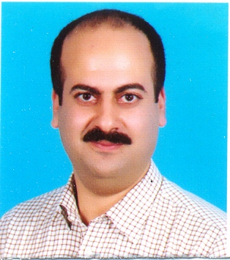
Personal Data:
- Age : 39 years
- Religion : Muslim
- Marital Status : Married ( 3 kids)
- Military case : Exemption

Education:
- Tourism & hotels – Kitchen Dep.

Computer Skills:
- Good using a computer.

Language Skills:
- Arabic : Mother tongue
- English : Good

Experience:
- (15/6/1992 – 15/9/1992)
  - Scheherazade Hotel – kitchen – sweet dep.
- (15/9/1992 – 20/8/1996)
  - Atlas Hotel – Kitchen.
- (28/12/1996 – 13/2/1998)
  - Abu Dhabi Hotel – Security officer
- (1/3/1997 – 27/3/1997)
- United Arab Emirates (Ministry of Interior) – fire fighting training for civilian.
- (1 /5/1997 – 6/6/197)
- Abu Dhabi Gulf Hotel – Oriental cook training.
- (24/2/1998 – 24/6/1999)
- ADMAK general contraction Co. – Cook
- (26/9/1999 – 15 /1 / 2000)
- Abu Dhabi national hotels Co. A.D.N.H. Co. Catering Division, AL Ain – Arabic cook
- (7/7/2000 – 12/12/2000)
- MORAIK Development & Oil field services – Arabic Chef
- ( 13/12/2000 – 7/7/2001)
- MORAIK – Arabic Chef
- ( 2002 – 2004)
- D. Diet Co. – General Chef
- ( 2005 – 2007)
- SAAD SPECIALIST HOSPITAL – General Chef
Personal skills
- Ability to work in all work environments
- Ability to learn and to gain more skills
- Ability to work under pressure
- Working in team work or individually.

